**Community-Built Playground**

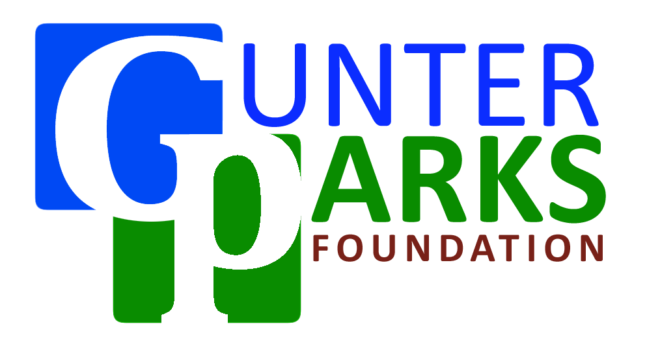

**Sponsorship Information Packet**

Playground Design inspired by Gunter Elementary Students

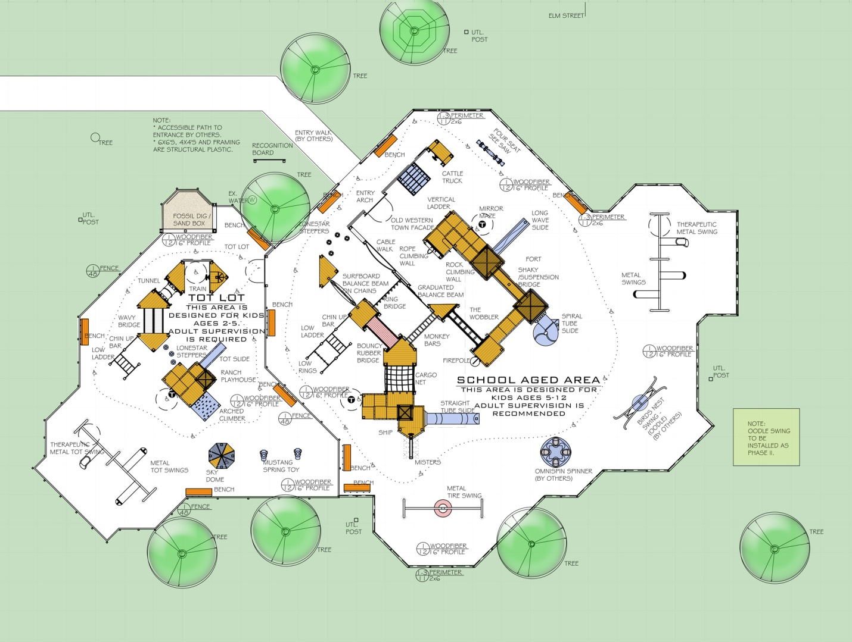

**Sponsorship Recognition**

**Logo and Message Placement**

Our message will be spread throughout Grayson County through a variety of media methods. As a sponsor, we will place your corporate name and logo on printed material including:

* Newsletters
* Flyers
* Brochures
* Direct Marketing Mailers
* Invitations
* Signage at events

**Media Coverage**

We will take every opportunity to thank our major sponsors through the media to include:

* Identifying major contributors in press releases
* Recognizing major contributors during interviews

**Internet Visibility**

All sponsors will be recognized on our website. Depending on contribution level you will receive:

* Logo placement on the homepage and/or sponsor page
* Cross linking to your homepage
* Inclusion of event photos in our photo gallery

**Visibility of corporate Representatives**

Major sponsors will be invited to participate as honored guest at all significant events to include:

* Ground breaking ceremony
* Ribbon cutting at grand opening ceremony
* Introduction as an esteemed guest at designated events

**Long Term Recognition**

Recognition will not end with the ribbon cutting ceremony. Your sponsorship will be permanently memorialized as part of the playground on our donor board at the playground site.

**Be Creative**

Do you have your own idea on how we can credit your generous contribution? Let us know!

**Sponsorship Levels**

**Diamond Sponsor $25,000**

* Special recognition permanently placed at the site on donor wall
* Recognition on website homepage with logo displayed and preferred

placement on sponsor page

* Logo included on all printed materials
* Invitation to attend all newsworthy events
* Invitation to ground breaking with preferred recognition
* Recognized at ribbon cutting ceremony
* Business name and logo on build t-shirts
* Corporate information included in media/press packet

**Platinum Sponsor $10,000**

* Platinum level recognition permanently placed at site on donor wall
* Recognition on website homepage and logo placement on sponsor page
* Invitation to attend all newsworthy events
* Invitation to ground breaking with preferred recognition
* Recognized at ribbon cutting ceremony
* Corporate information included in media/press packet

**Gold Sponsor $5,000**

* Gold level recognition permanently placed at site on donor wall
* Recognition on website
* Invitation to ground breaking with preferred recognition

**Silver Sponsor $2,500**

* Silver level recognition permanently placed at site on donor wall
* Recognition on website
* Invitation to ground breaking

**Bronze Sponsor $1,000**

* Bronze level recognition permanently placed at site on donor wall
* Recognition on website
* Invitation to ground breaking

**Family Sponsor $500**

* Family Sponsor level recognition permanently placed at site of donor wall
* Recognition on Website
* Invitation to ground breaking

**Components available for Sponsorship**

In addition to our corporate sponsorships, we also have playground components available for sponsorship. All playground sponsors will be recognized on our website, as well as permanently recognized at the playground site on our donor wall. Component sponsorship opportunities are listed to the left and are available on a first-come, first-serve basis. If there is a component that you desire to sponsor, please contact a committee chair as soon as possible to confirm sponsorship and forward your sponsorship form with payment.

**Our total estimated amount that we need to raise for this project is: $200,000**

|  |  |
| --- | --- |
| Component Name | Price |
|  | Ranch Playhouse | $2,000 |
|  | Ship | $2,500 |
|  | Fort | $1,800 |
|  | Mirror Maze | $2,500 |
|  | Cattle Truck | $1,000 |
|  | Train | $800 |
|  | Sandbox with Fossil Dig | $1,900 |
|  | Twisty Slide | $4,500 |
|  | Slide | $1,500 |
|  | Tot Slide | $1,100 |
|  | Bouncy Bridge | $950 |
|  | Cable Bridge | $750 |
|  | Ladder | $925 |
|  | Ladder | $925 |
|  | Rings | $2,200 |
|  | Low Rings | $1,100 |
|  | Monkey Bars | $1,800 |
|  | Low Monkey Bars | $1,000 |
|  | Tot Monkey Bars | $1,000 |
|  | Pods | $1,500 |
|  | Bar | $350 |
|  | Surf Board | $550 |
|  | See-Saw | $3,500 |
|  | Omni Spinner | $6,800 |
|  | Fire Pole | $1,050 |
|  | Rope Climb | $1,150 |
|  | Shaky Bridge | $1,550 |
|  | Rock Climb Wall | $1,750 |
|  | Sky Dome | $1,650 |
|  | Wavy Bridge | $1,250 |
|  | Net | $1,650 |
|  | Arched Climber | $1,500 |
|  | Tunnel | $1,750 |
|  | Lone Star Steppers | $350 |
|  | Tot Steppers | $350 |
|  | Phones | $550 |
|  | Misters | $2,700 |
|  | Bouncy Animal | $1,100 |
|  | Bouncy Animal | $1,100 |
|  | To-Fro Swings | $3,400 |
|  | Accessible To-Fro Swings | $3,700 |
|  | Tot Swings | $3,600 |
|  | Accessible Swing | $3,600 |
|  | Tire Swing | $3,800 |
|  | Bench x8 (cost is per bench) | $450 |

How to Contribute

Thank you for supporting the Gunter Community-Built Playground Project. When you become a playground sponsor, you choose your level of sponsorship by purchasing a playground component or making a donation to the playground fund. Component sponsorship opportunities are listed and available on a first-come first-serve basis.

Corporate sponsorship levels are:

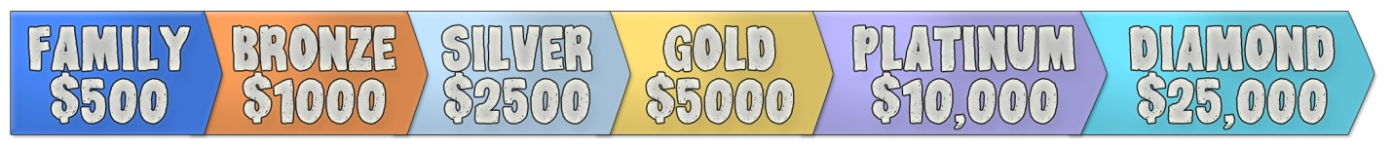

Please make donations payable to:

Gunter Parks Foundation

P.O. Box 411

Gunter, TX 75058

_________________________________________________________________________________________________________

Business, Organization, or Individual Name

____________________________________________________________________________________________________________________________________________

Address

____________________________________________________________________________________________________________________________________________

City, State, Zip

________________________________________ _______________________________________________________________________________________________

Phone Email

Level of Sponsorship:

* Diamond _______________________________________________________________________
* Platinum Amount Enclosed
* Gold
* Silver
* Bronze
* Family
* Component Sponsorship _______________________________________________________________________

Name of Component/Components

*All donations are tax deductible, as the Gunter Parks Foundation is a nonprofit 501(c)3 organization*

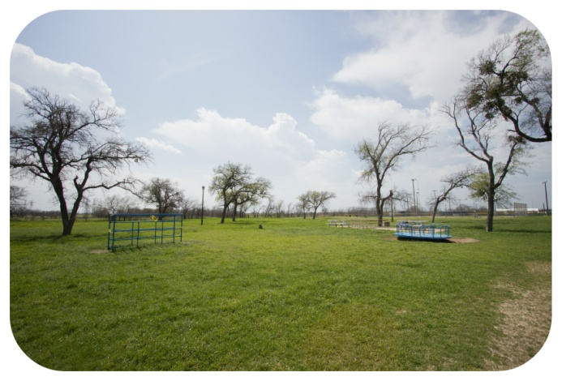

**Project Committee Information**

**General Coordinator**: Nancy Nevil

**Public Relations**: Lauren Miller

**Fundraising**: Rick Cohagan and Jan Pope

**Materials/Donations**: Cheyrl Cohagan and Casey Gann

**Design and Art:** Suzanne Brackeen

**Children's**: Debbie Locke and Leslie Matiko

**Volunteer Recruitment**: Russell Leonard and Lynn Reed

**Special Needs**: Mia Rossi

**Food and Catering**: Jessica Seay

**Tools**: Position Available

